GAZING MATHEMATICALLY:
SEEING-AS AND SEEING-IN

John Mason
john.mason@open.ac.uk

Abstract
Might it be that ‘seeing something as’ something else not only pervades mathematics, as well as other subjects, but that for some learners at least, it requires effort and assistance? Examples are given from both algebra and geometry of seeing-as and seeing-in (seeing one object or form as a component of another) in order to stimulate the reader to experience the work with attention required.

Introduction
A recent day out in London comprising the Royal Academy’s Summer Exhibition, and Ralph Fiennes dramatically reciting the Four Quartets has inspired the following observations.
To gaze upon some discerned whole,
Not tentatively nor, as transient,
Not just with body, heart and head, but spirit too,
May lead to a threshold at the arch of experience,
Where through gleams that inexpressible world of form.
Cave-freed, however temporary,
To express what is experienced is to over stress,
To overlay the unexpressed, the as yet inchoate,
Hiding totality from view.
One of the strands of the Four Quartets is the futility yet necessity of trying to express the ineffable.
Promenading through the Summer Exhibition, the walls literally covered, with over a thousand objects declared by their presence to be works of art, occasionally something speaks to my condition. A connection is made with my past experience, and the object is seen-as something else, metaphorically saying something deeper, more abstract, certainly more general. Sometimes it is not the whole of an object but some part, so that what is discerned is meaning seen-in. A discerned whole within a whole is seen-as.
I offer in what follows some possible mathematical examples of seeing-as and seeing-in

Algebra Example
Often an algebraic expression looks complicated. It may be simplified by factoring (thanks to computer algebra!) or made up of components most of which are themselves of some standard form (difference of two squares? squares of differences? Pythagorean-like expressions?). Gazing at an expression, not mindlessly, yet not mindfully if that means being dominated by the analytic logic of cognition, can bring to the fore (not so much to mind as to awareness in the form of a possible action) recognition, realisation of the possibility of an alternative form.

Characterising Bilinear Expressions
Sundaram’s generalised grid consists of a two-way infinite grid whose rows and columns are in arithmetic progression (but possibly different differences). A bilinear expression of the form E = axy + bx + cy + d appears while characterising the numbers which can appear in the grid. The same appears when counting the number of moves in Leapfrogs (Dudeney 1917: problems 215, 216, 217) or the number of perforations in a block of stamps, among many other places.
aE = a²xy + abx + acz + ad = (ax + c)(ay+ b) + ad – bc
and the constant term ad – bc is redolent of determinants. Consequently a number N can be expressed as axy + bx + cy + d if and only if aN + bc – ad is the product of two numbers, of the form (ax + c) and (ay + b). In other words, aN – (ad – bc) is the product of two numbers congruent to b and to c modulo a, respectively.
Sundaram’s grid (PMTheta webste; see also Havil 2009; Honsberger 1970, Ramaswami 1934) can be seen as a sieve (Wikipedia website), by starting with the positive integers and removing all numbers expressed as jk + j + k for some integers j and k.
With experience, the sight of a bilinear expression is likely to bring to the surface this manipulation, this form. Algebra is full of such alternative forms (see for example Carr 1886 whose book inspired Ramanujan).

The Geometrically Pervasive Nature of Scaling
Given two points C₁ and C₂ in the plane, for any point P, scaling P from C₁ as centre by a scale factor of σ₁ to P₁, then scaling P₁ from C₂ as centre by a scale factor of σ₂ to P₂₁ can be depicted as on the left in Figure 1.
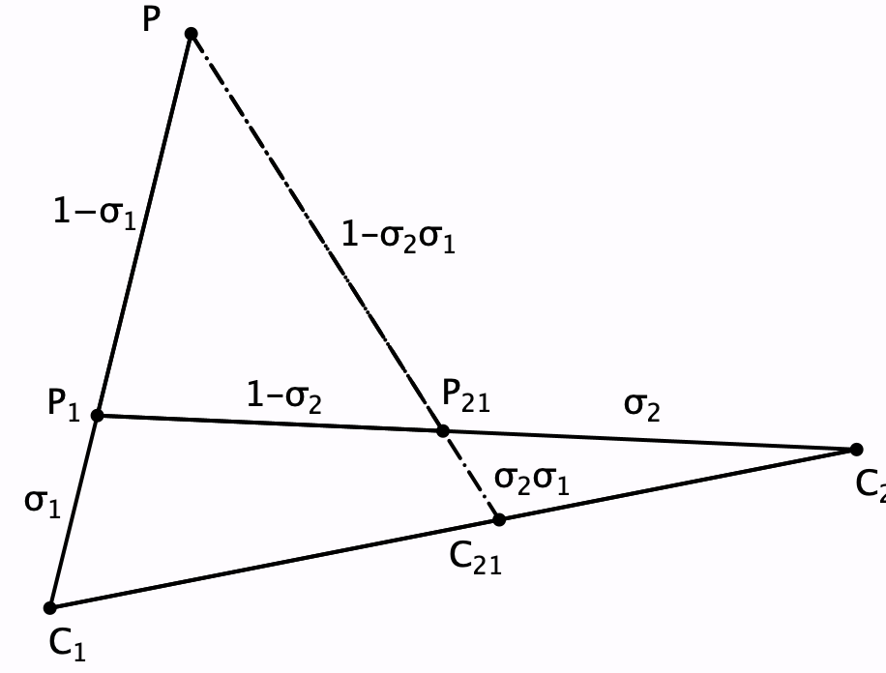
Figure 1: composition of two scalings from different centres
The two scalings together can be seen-as a single scaling from the point C₂₁ by a scale factor of σ₂σ₁ as depicted in Figure 1. Notice that simple gazing is not enough to see-as. Attention needs to be directed and certain features stressed, such as “the point being scaled”, “the centre of scaling”, ”the scale factor”, at least at first.
The overall configuration is ubiquitous, and not just in geometry, for it can be seen-as depicting the relationship between vertices and edges of a complete graph on four points: vertices of the graph are lines of the configuration, and vertices are joined in the graph when the corresponding lines intersect in a point of the configuration. Three points lie on a line of the configuration when the corresponding vertices belong to a circuit in the graph (Coxeter 1950).
In the configuration, there are 4 lines each with three points of the configuration, and each pair of lines of the configuration meets in a single point of the configuration. The reason for repeating “of the configuration” is that learners often want lines that cross each other to be considered to intersect, when that is not part of the configuration. The notion of a configuration here refers to two sets, one of objects thought of as ‘points’, and one of subsets of the points, thought of as ‘lines’. Thus the notion of a configuration abstracts the geometrical context of points and lines in some larger (possibly non-Euclidean) space, to a pair of sets with some specified properties. For example, self-crossing quadrilaterals have to be seen-as a configuration not as a set of points in the Cartesian plane.
The evident symmetry of the configuration suggests that there are many (in fact 24) different ways of the configuration being seen-as the composition of two scalings of some point from two centres, by two scale factors. Gazing, then controlling the focus and locus of attention is one way to experience this multiplicity.
The left hand side of Figure 2 depicts the composition of two scalings (in how many ways can such a composition be discerned in the diagram?), and the right hand side depicts the composition of three scalings.
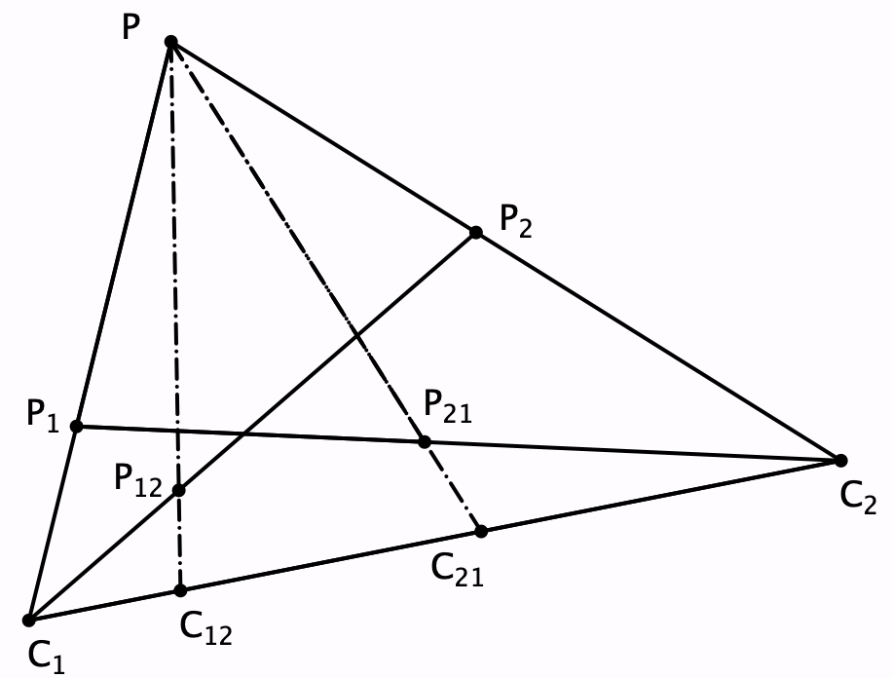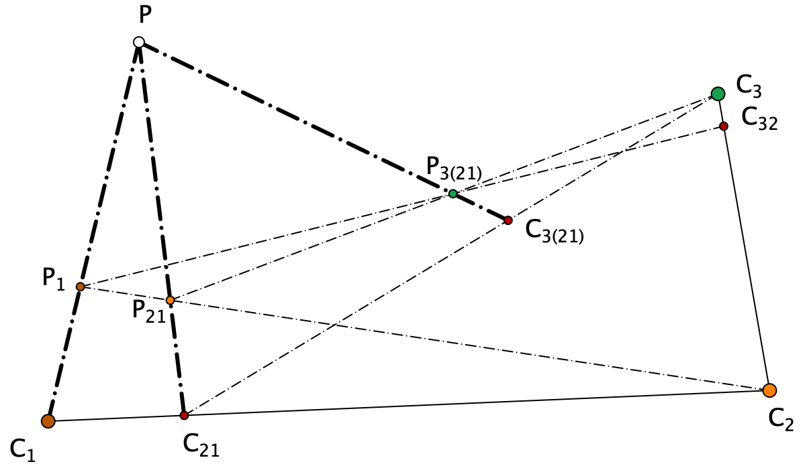
Figure 2: composition of two scalings in either order,
and of three scalings
How many versions of a single scaling, a composition of two scalings, and a composition of three scalings can be found in the diagram?
Ceva’s theorem says that for a triangle with points dividing the edges in specified ratios, the three Cevians (lines from a vertex to the division point on the opposite sides) will be coincident if and only if the product in order around the triangle of the division ratios is 1. The Ratio Sum theorem says that the sum of the ratios on two edges of the triangle from a vertex is the ratio in which the Cevian Point divides the Cevian from that same vertex. Figure 3 depicts the configuration behind Ceva’s theorem and the Ratio-Sum theorem which again can be reasoned by seeing-in the full configuration appropriate versions of the scaling diagram.
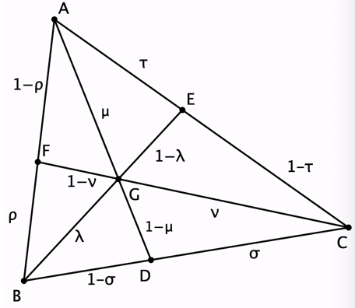
Addressing such questions may serve to stimulate a desire to see-in through the movement of attention. The overall configuration is known as Desargues’ theorem, for it characterises the associativity property of composing three scalings.

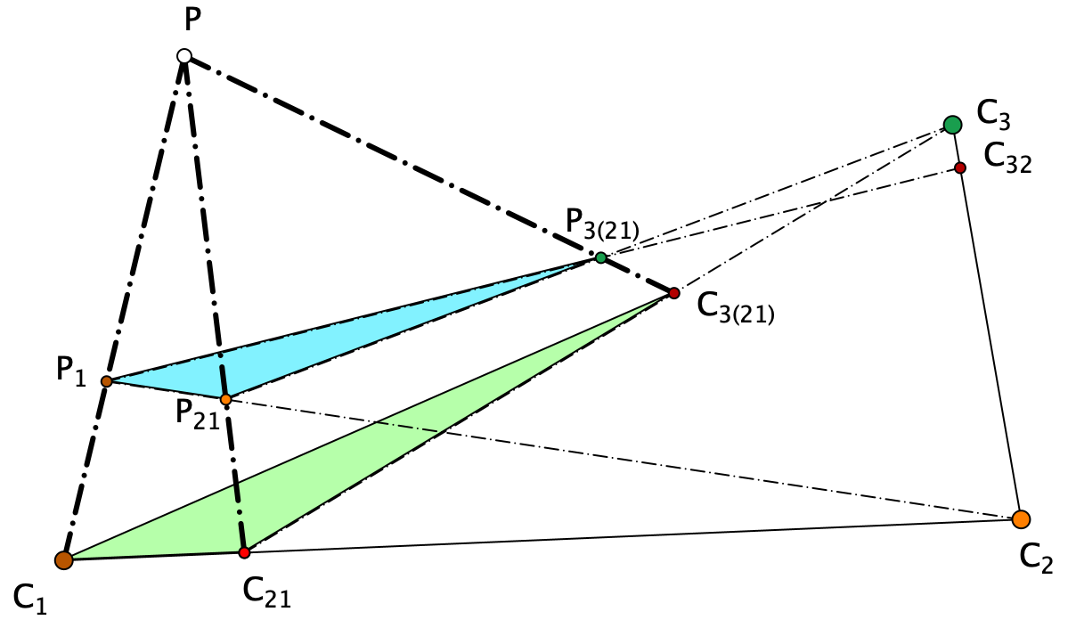
Figure 4: Composition of three scalings seen-as
a Desarguesian configuration of two triangles in perspective.

Reflections
My aim was to raise the question of whether the actions of seeing-as and seeing-in are as automatic and simple as might be supposed when observing mathematics lessons. Might it be the case that some learners never reach the point of appreciating these shifts of attention, these ways of experiencing in mathematics. Might there be some value in comparing notes with teachers of literature, in which seeing-as via metaphor, and seeing-in when discerning tropes and grammatical constructions is something that often requires work by the teacher?

Footnotes
Discerning wholes and gazing at them, holding them for a period of time is one way of attending to things (Mason et al 2005).
The arch of experience comes from Tennyson’s Ulysses.
Cave-freed refers to Plato’s Cave and the material world as a world of shadows of forms.
To express is to over stress (Mason et al 2005).

References
Carr, George Shoobridge (1886), A synopsis of elementary results in pure mathematics containing propositions, formulae, and methods of analysis, with abridged demonstrations. Reprinted by Chelsea, 1970, London. Fr. Hodgson. Cambridge. Macmillan and Bowes,
Coxeter, H. (1950). Self-Dual Configurations and Regular Graphs. Bull. Amer. Math. Soc. 56(5) pp. 413-455.
Havil H. (2009). Sundaram’s Sieve. Plus Magazine 50 (13). see website: plus.maths.org/content/sundarams-sieve
Honsberger, R. (1970). Ingenuity in Mathematics. New Mathematical Library #23. Mathematical Association of America. p. 75.
Mason, J. with Johnston-Wilder, S. & Graham, A. (2005). Developing Thinking in Algebra. London: Sage (Paul Chapman).
Ramaswami Aiyar, V. (1934). "Sundaram's Sieve for Prime Numbers". The Mathematics Student 2 (2) p. 73.

Internet Resources
PMTheta Website: www.pmtheta.com/sundaram-grids.html
Sundaram’s Sieve: en.wikipedia.org/wiki/Sieve_of_Sundaram
Wikipedia (en.wikipedia.org/wiki/Sieve_of_Sundaram).

